

**TEST PROJECT DOCUMENT**

**EMBEDDED SYSTEM**

WSC2017 TP16_JP_EN

Submitted by:

Name:

Member country/region:



**CONTENTS**

This Test Project proposal consists of the following documentation/files:

C_Program

Datasheet

(CAD)_Multi_Function_Clock.PDF

(CAD)_PIC_card.pdf

WSC2017_TP16_JP_Logo_Data.xlsx

(Program files that Competitors use)

(main components data sheet)

(schematic , board drawing)

(schematic , board drawing)

(logo data)

|  |  |  |
| --- | --- | --- |
|  |  |  |
|  |  |
|  |



INTRODUCTION:

**s**

Water level indicator & controller is a device used to on/off motor, as per requirement and

availability of water, automatically.

The purposed device features three modes of operation with four extra features which is switched

on/off by the user as per need.

This test project has following functions;

1. Display WSC logo
2. Mode Selection and settings
3. Mode Operations

BLOCK DIAGRAM

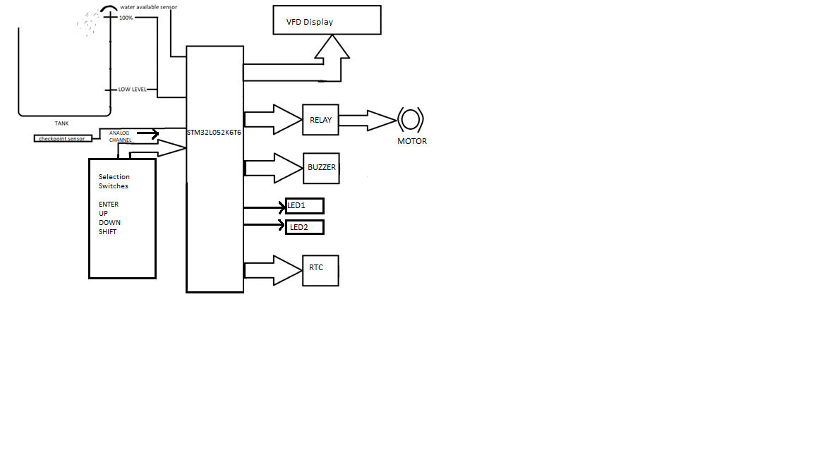

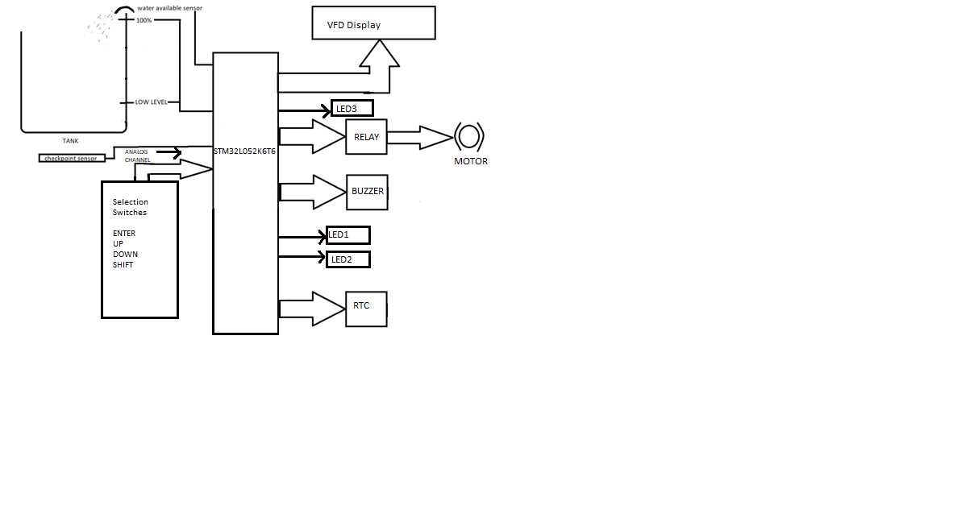



**DESCRIPTION OF PROJECT AND TASKS**

**TASK-1:** DISPLAY WSC LOGO

1. On Power up, **WorldSkills2017** logo should be there on Vacuum fluorescent display (VFD).

2. This logo should be there for 4 second.

3. Then the logo will move to the left & stay there for 1 second.

4. Then it will move to the right & stay there for 1 second.

5. After that the logo will move back to the center position & stay there for 1 second.

6. Then it will move upwards & stay there for 1 second.

7. Then it will move downwards & stay there for 1 second.

8. After that the logo will again come back to the center position.

**TASK-2: RTC SETTINGS**

1. Set time, day and date on Real Time Clock.

2. Display Time in the first line.

3. Display Day in the second line.

4. Display Date in the third line.

**TASK 3: SETTING MODES OF OPERATION:**

**Sensors Used:**

1. Checking-Point Sensor:

This sensor is placed in the pipe which runs water to the house from the main supply. It is the start point in Mode 1.

1. Water availability Sensor:

This sensor is placed inside the overhead tank in the position where the water falling into the tank, falls on it.

1. 100% indicator sensor:

It senses for the availability of water at 100%.

1. LOW LEVEL sensor:

This sensor can be placed anywhere in the tank. It is used to indicate for low water level in the tank. LOW LEVEL is user defined.

The mode of operation depends on the water availability in the region where this device is being installed.

**MODE 1:**

This mode is basis for all other modes of operation. It carries the basic functionality of the device.

1. In this mode, We first check for the availability of water at CHECKPOINT sensor, if water is present then a slight delay is given before checking again for water available at checkpoint sensor. This delay is user defined.
2. After delay if, water is still present, microcontroller is programmed to ON MOTOR, otherwise the operation is returned back to check for water at CHECKPOINT sensor.
3. MOTOR gets ON for defined RUN TIME before further operation, this RUN time is also used defined. After RUN time, microcontroller senses for the availability of water at WATER AVAILIBILITY SENSOR and the level of water in the tank.
4. If water is present and tank is not full, the motor remains ON, otherwise if any of the condition is not true, motor is turned off, and the operation jumps to checking availability of water at checkpoint sensor.

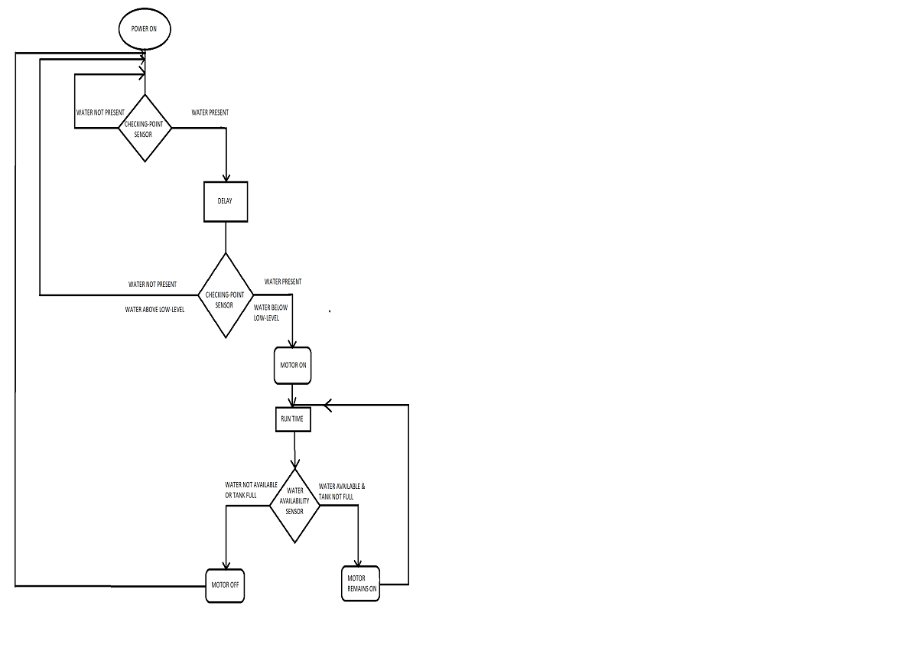

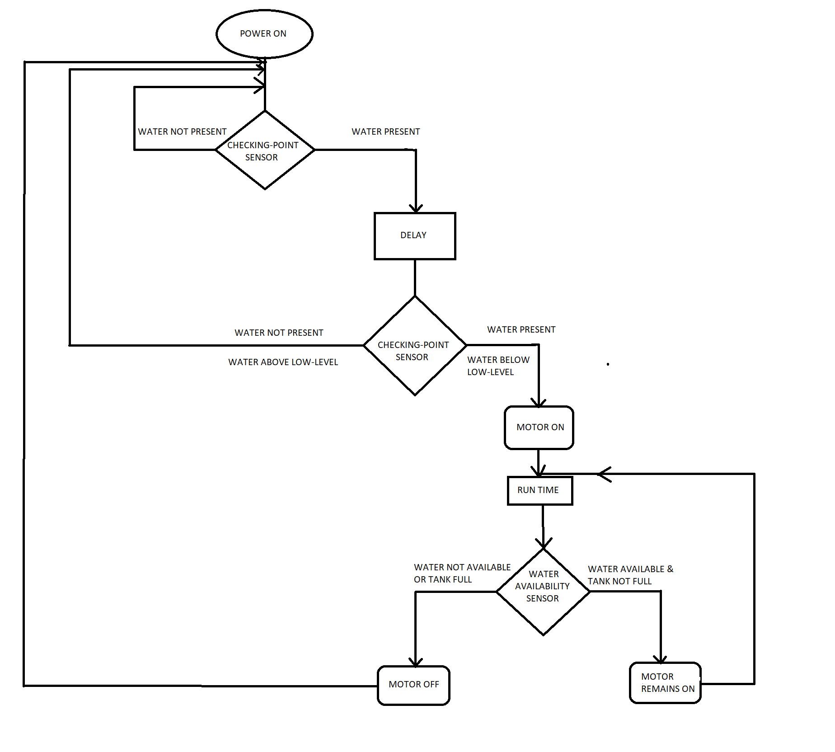



**MODE 2:**

This mode is used where water is not available to checkpoint sensor without the pressure exerted by motor, so motor must be turned on and off regularly to check for water. This ON time and OFF time are set by users.

1. During ON time, motor is turned ON, if the water reaches checkpoint sensor then operation is shifted to MODE 1.
2. During OFF time, motor is OFF, if water reaches checkpoint sensor then again operation is shifted to MODE 1.

**MODE 3:**

This mode is the more refined version of mode 2. Here motor is not turned ON & OFF to check for water whole day but instead, we define slots for defined period of time, in which motor is turned ON and OFF repeatedly. This mode is for those regions where, authorities have defined time of release of water, so person can specifically set those slots in given time to turn motor on. It works as MODE 2 during ON and OFF time in given slot time.

**SOME ADDITIONAL FEATURES:**

|  |  |  |
| --- | --- | --- |
|  |  | 4 of 18 |
|  |  |
|  |

1. HOLD SYSTEM:

If ON, whenever power cuts, it waits for 3 minutes then resumes. It is for region and time where power fluctuations is a concern. During these 3 minutes, no operation is done, only time is displayed on VFD.

1. MOTOR ON, if LOW-LEVEL:

This feature works in MODE2 & 3, if switched ON and water falls below low level, motor is switched ON without any further sensor checking.

1. LEVEL not INCREAMENT:

This feature works in the condition when motor is turned ON and water level is not increasing in the tank for the SET time. It will automatically alert user for any leak during that period by switching ON buzzer for five minutes.

1. 100% LONG:

This feature alerts user by buzzing an alarm for five minutes if water is stable at 100% for the SET time.

INSTRUCTIONS TO THE COMPETITOR



1.Please write a program of the remaining part of the source code by using C language, and complete TASK1, 2, 3 in Time limit (4 hours).

2.The logo displayed should be very clear.

3.There should be no pixel distortion while moving the logo.

4.The date, time and day settings on RTC should be in real time

1. LED1 gets ON when water is available at checkpoint sensor and LED2 gets ON when water is available at water availability sensor.
2. LED3 will get On when motor is On.

|  |  |
| --- | --- |
|  |  |

# EQUIPMENT, MACHINERY, INSTALLATIONS ANDMATERIALS REQUIRED

|  |  |  |  |  |  |  |  |  |  |  |  |  |
| --- | --- | --- | --- | --- | --- | --- | --- | --- | --- | --- | --- | --- |
|  | **ITEM** |  |  | **QUANTITY** |  |  | **MATERIAL** |  | **DESCRIPTION** |  | **NOTES** |  |
|  |  |  |  |  |  |  |  |
|  |  |  |  |  |  |  |  |  |  |  |  |  |
|  |  |  |  |  |  |  |  |  |  |  |  |  |
|  | PIC Card | | 1 | |  |  |  |  |  |  |  |  |
|  |  | |  | |  |  |  |  |  |  |  |  |
|  | Target Card | | 1 | |  |  |  |  |  |  |  |  |
|  |  | |  | |  |  |  |  |  |  |  |  |
|  | Stack Card | | 1 | |  |  |  |  |  |  |  |  |
|  |  |  |  |  |  |  |  |  |  |  |  |  |

